**Faculty of Information Technology**

**Semester 1 2020**

**FIT5101 – Enterprise Systems**

**ASSIGNMENT 2**

***(Individual assignment only)***

**BUSINESS PROCESS INTEGRATION: A PRACTICAL APPLICATION OF S/4 HANA**

Mark allocation: 100

Weighting: 20%

Due date: Sunday 31st May 11:55PM

Assignment hand in: FIT5101 Via Moodle

Word Length: No limit

Reference count: N/A

Working strategy: Work Individually

**Aim**:

Be able to follow practical instructions to complete a range of business process transactions that follow a logical flow in order to create, sell and procure a newly developed bicycle using S/4 HANA. The outcomes will be a selection of correct transaction screen shots and explanation of the transactions themselves.

**Key Deliverables**:

* Create the master data for a newly developed Mountain Bike to include, BOM, Routings and work centres
* Complete the sales order processing cycle to sell the Mountain Bike to a customer
* Complete the procure to pay processing cycle to purchase additional accessories for the Mountain Bike
* Download appropriate screen shots to demonstrate you have correctly carried out the transactions
* Create explanations to explain the screens and their impact on the S/4 HANA system

­­­

**Learning Outcomes: at the end of this assignment you will be able to:**

1. Demonstrate your ability to correctly follow instructions to create master data for a newly developed product
2. Demonstrate your ability to correctly complete the sales order processing cycle through to accepting and processing payment from a customer
3. Demonstrate your ability to correctly complete the procure to pay processing cycle through to payment to a vendor
4. Demonstrate your ability to understand the transactions and the effect of those transactions have in the S/4 HANA system by the use of explanations
5. Demonstrate your ability to correctly identify a set of screens from the above transactions to support your assignment

**Instructions*:***

|  |
| --- |
| You have been presented with the following case scenario which requires you to complete a range of process tasks with regard to creating a new bicycle called the***GT Mountain Bike***. Once the bicycle has been completed you will be creating and processing a sales order and create and process a purchase order. Additionally, you will be required to submit a set of specified deliverables which are outputs from the different processes and discuss their impact on the S/4 HANA system. An answer sheet template has been provided for this purpose and is included at the end of this assignment. |

**Scenario:**

GBI, after considerable market research involving vendors and customers, has realised that there is potential for a new style of bicycle to be developed. The new bicycle is called the ***GT Mountain Bike*** and is displayed below:

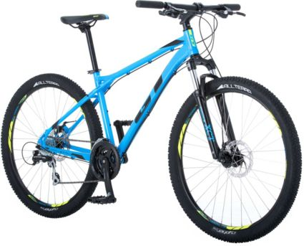

The GT Mountain Bike details need to be entered into the system before the bicycle can be manufactured and sold.

NOTE: 1) All data relates to the Plant in Dallas unless otherwise specified.  
 2) If any of the required data fields are not specified, use the same data that you entered in the   
 relevant workshop exercises.  
 3) Replace ### with your user id number.

**Task 1 Materials Management**

1. Create the finished material for the GT Mountain Bike. You will need to define a new *Finished Product*, The **GT Mountain Bike ###** with item code **GTMB1###** (Where ### your SAP user id.). The specifications for the GT Mountain Bike are similar to the Mongoose Mountain Bike except for the following:
   * 1. Description **GT Mountain Bike ###**
     2. Gross Weight: **28 kg**
     3. Net Weight: **28 kg**
     4. Standard Price: **$USD1800**

**NOTE: Do not use the copy function to create the Mountain Bike master data.**

1. Create a new *Raw Material,* Bicycle Valve, VALV1###. The specifications for the valve are as follows:

Material: VALV1###

Industry Sector: Retail

Material Type Raw materials

Views: Basic Data 1

Basic Data 2

General Plant Data / Storage 1

Accounting 1

Plant: DL00

Storage Location: RM00

Description: Bicycle Valve

Base UOM: EA

Lab/Office: 002

Gross & Net Weight: 500 Milligrams

Ind. Std. Desc: Tyre Valve 5mm

Valuation Class: 3000

Standard Price: $USD 1,50

Price Control Ind: S

1. The GT Mountain Bike’s bill of materials (BOM) needs to be entered into the system so that the various components can be recognised by the facilities production planning and material requirements planning systems.   
     
   The GT Mountain Bike is made up of the following subassemblies (semi-finished products) and Raw Materials as shown in the Material List below. These materials already exist in S/4HANA. Create the following production BOM for the Dallas plant. **Note** that some of the semi-finished products may already be defined (Check this before entering the BOM).

|  |  |  |
| --- | --- | --- |
| **Item Code** | **Material Description** | **Material Type** |
| ORWA1### | Wheel Assembly | Semi-Finished Product |
| OFFR1### | Off Road Frame | Semi-Finished Product |
| DGAM1### | Gear Assembly | Semi-Finished Product |
| BRKT1### | Brake kit | Semi-finished Product |
| PEDL1### | Pedal Assembly | Semi-Finished Product |
| ORTR1### | Tire | Raw Material |
| ORTB1### | Tube | Raw Material |
| ORWH1### | Aluminium Wheel | Raw Material |
| HXNT1### | Hex Nut | Raw Material |
| LWSH1### | Lock Washer | Raw Material |
| BOLT1### | Socket Head Bolt | Raw Material |
| VALV1### | Valve | Raw Material |
| PCKG1### | Packaging | Raw Material |
| WDOC1### | Warranty Document | Service Material |

GT Mountain Bike (1)

Warranty (1)

Pedal Assembly (2)

Off Road Frame  
 (1)

Gear Assembly  
 (1)

Packaging (1)

Brake Kit (1)

Wheel Assembly (2)

Valve  
 (1)

Aluminium Wheel  
 (1)

Socket Head Bolt  
 (1)

Tyre  
 (1)

Tube  
 (1)

Hex Nut  
(1)

Lock Washer  
 (2)

1. The production process for the GT Mountain Bike requires the following work centres:

|  |  |
| --- | --- |
| D1-### | Gear Assembly |
| D2-### | Frame Assembly |
| D3-### | Final Assembly |
| D4-### | Test & Pack |

1. The Cost Centre is NAPR1000
2. You now need to create the Dallas Plant’s Routing for the GT Mountain Bike for production.  
   The Routing is:

|  |  |  |  |
| --- | --- | --- | --- |
| Operation | Work Centre | Control | Description |
| 0010 | D1-### | PP01 | Assemble Raw Materials |
| 0020 | D2-### | PP01 | Final Assembly |
| 0030 | D3-### | PP01 | Paint |
| 0040 | D4-### | PP01 | Final Test |

1. Ensure that you release the Routing for Costing.
2. The GT Mountain Bike is ready for production. However, before it is fully available, 5 GT Mountain Bike prototypes have been produced to test the proof of concept. These bikes need to be added to the Dallas Plant inventory for Finished goods. They will be entered for unrestricted use and will be entered without a Purchase order.

**Task 2 Sales and Distribution.**

Due to extensive marketing for the new GT Mountain Bike, GBI has received the following Purchase Order from Foster Cycles ###.

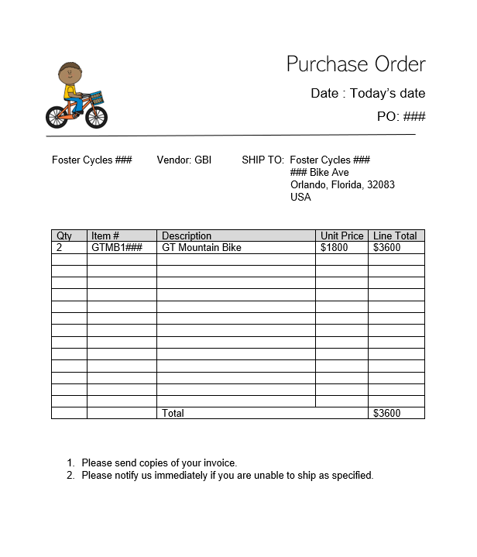

You now need to complete the fulfilment process for this Purchase Order. This includes the following:

1. Create the new customer, *Foster Cycles ###*. Use the same data as The Bike Zone customer (ref SD workshop) **except** **where this data has been included in the Purchase Order**.
2. Create a Sales Order with a required delivery date one month after today.  
   (Hint: Use *Item Conditions* to specify the Unit Price. No discounts apply)  
   **Do not create a Customer Inquiry or Quotation.**
3. Complete the Delivery Process
4. Create an Invoice for the Customer (Ignore any warning message relating to Output Determination)
5. Process the payment in full from the customer.

**Task 3 Procurement**

The sales of the GT Mountain Bike have been steadily increasing. Many of the customers are now enquiring about possible accessories they can purchase. Many of the enquiries have been in relation to the road helmet (RHMT1###).

1. You have reviewed the inventory levels in the **Miami** plant for this material and realise that you need to purchase another 20 road helmets.

The details for the purchase are:

* + Material: **RHMT1### (**This is a Trading Good - Procured externally and sold again  
     without being processed further)
  + Quantity: **20**
  + Price: $25
  + Vendor: **103###** Dallas Bike Basics
  + Delivery date: **2 weeks** from today’s date
  + Purchasing Organisation: **GBI US**
  + Company Code: **US00 GBI**

1. Create a purchase order for the required materials to be sent to Dallas Bike Basics (vendor).
2. Create a goods receipt for the materials.
3. The following invoice arrives. Process it and make the payment to the vendor.

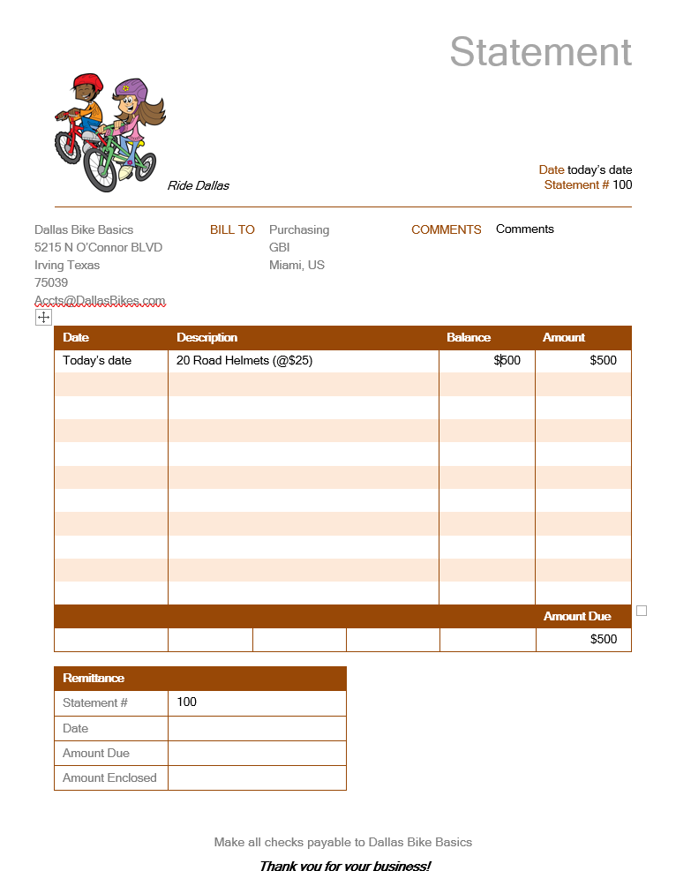

**\*\* END OF SCENARIO \*\***

**FIT5101 – Enterprise Systems**

Semester 1, 2020

**ASSIGNMENT 2: ANSWER SHEET TEMPLATE**

**BUSINESS PROCESS INTEGRATION: A PRACTICAL APPLICATION OF S/4 HANA**

|  |  |
| --- | --- |
| **Name: RASHMITHA KARKERA** | **Student ID: 30438101** |
| **Tutor’s Name: SHAHID HOQUE** | **Tutorial Day**  **and time: THURSDAY 2PM** |
| **SAP User ID: LEARN--531** |  |

**INSTRUCTIONS:**

1. **Only provide the screen shots you have been asked to provide.**
2. **Your tutors will mark your answers from this template – please ensure the screen shots are clear and large enough for marking**
3. **Please type your answers to the questions in the space provided beneath each screen shot – make sure the answers are as clear as possible thus allowing for maximum mark allocation**
4. **Please ensure your SAP User ID number is correct and included as part of the transactions that you create – incorrect SAP User ID numbers used for any one transaction will make the transaction unmarkable.**

|  |  |
| --- | --- |
| **Deliverable: Materials Management** | **1. Display the Accounting 1 view of Raw Material VALV1###** |
| **Screen shot: (6 marks)** | |
|  | |
| **Provide an explanation of the transaction you are displaying in the box provided including an explanation why the Material Master data is represented as separate views. (3 marks)** | |
| The Accounting 1 view includes the information regarding the Material “Bicycle Valve’s” Accounting Department.  The reason the Material Master Data is represented as separate views is, that it consists of large data. So, SAP breaks down this large data into separate categories namely the views for easier understanding and accessing the data. | |

|  |  |
| --- | --- |
|  |  |
| **Deliverable: Production Planning** | **2. Display the Multi-Level BOM for your GTMB1###** |
| **Screen shot: (10 marks)** | |
|  | |
| **Provide an explanation of the transaction you are displaying in the box provided including an explanation of the link between the BOM and the MRP (the box will expand as you type: (4 marks)** | |
| The transaction “Multilevel BOM” displays the list of items utilised in the building of the GT Mountain Bikes.  The BOM includes the components utilised in the development of the material” GT Mountain Bike”, whereas the MRP is the planning that is done, when we need to order new materials (depends on the stock availability).  The link between the BOM and MRP is that the BOM is used in the MRPS because we need to know the components required/available for the purpose of Material Requirements Planning. | |

|  |  |
| --- | --- |
|  |  |
| **Deliverable: Production Planning** | **3. Display the Routing Operation Overview for your GTMB1###** |
| **Screen shot: (8 marks)** | |
|  | |
| **Provide an explanation of the transaction you are displaying in the box provided including an explanation of a routing and a work centre with regards the GT Mountain Bike (the box will expand as you type): (4 marks)** | |
| The snapshot displayed above provides us with an overview about the Routing operation for the GT Mountain Bike. It shows the steps involved in the developing of a Finished Goods i.e. “GT Mountain Bike”.  The work centre includes data about the capacity, cost, department, availability in the production of GT Mountain Bikes. During the routing, the work centres schedules as per the ordered sequence for the finishing of the final product. | |

|  |  |
| --- | --- |
|  |  |
| **Deliverable: Sales and Distribution** | **4. Display the Stock Overview after the issue of GTMB1####** |
| **Screen shot: (10 marks)** | |
|  | |
| **Provide an explanation of the screen you are displaying in the box provided including what is meant by stock overview and unrestricted use (the box will expand as you type: (3 marks)** | |
| The snapshot displays the information about the stock availability. The stock contains a quantity of 10 bicycles. The number is same throughout because we have only one stock location and the stock location are within the plant.  The bicycle stock is set to unrestricted use because the stock can be utilised for everything. | |

|  |  |
| --- | --- |
|  |  |
| **Deliverable: Sales and Distribution** | **5. Display the Journal Entry for payment associated with the sale of GTMB1###** |
| **Screen shot: (6 marks)** | |
|  | |
| **Provide an explanation of the transaction you are displaying in the box provided including an explanation of a General Ledger account and profit centre (the box will expand as you type): (4 marks)** | |
| The Journal Entry is the result of the incoming payments for the sale of GTMB1531. It displays the financial statements of the sales done.  The General Ledger Account maybe defined as the collection of all the financial account used by the company code.  The profit centre includes cost, and the revenue generated from the sales. | |

|  |  |
| --- | --- |
|  |  |
| **Deliverable: Sales and Distribution** | **6. Display the Document Flow for the sale of GTMB1####** |
| **Screen shot: (4 marks)** | |
|  | |
| **Provide an explanation of the screen you are displaying in the box provided including the significance of the material and the accounting documents (the box will expand as you type): (4 marks)** | |
| The document flow represents the order of flow of the document regarding delivery, material and accounting for the GT Mountain Bike. The employ can check the status at any point of time. It shows that for the delivery issued, the material is determined, and then the payment is transferred into the account.  It also links the set of document numbers as per the order.  The material document includes the goods that has been issued for the delivery.  The accounting document incudes the payment that has been cleared after the invoice was obtained. | |

|  |  |
| --- | --- |
|  |  |
| **Deliverable: Procurement** | **7. Display My Purchasing Document Items for 103### (After task 3d)** |
| **Screen shot: (4 marks)** | |
|  | |
| **Provide an explanation of the screen you are displaying in the box provided including the meaning and significance of the Purchasing Group (the box will expand as you type): (3 marks)** | |
| The purchasing document items maintains the different documents issued for the supplier 103531- Dallas Bike Basics. Here it maintains purchase order, good receipts and the supplier invoices. The employees can keep a track on the status.  The purchasing group provides us the location of the supplier. | |

|  |  |
| --- | --- |
|  |  |
| **Deliverable: Procurement** | **8. Display the Stock Overview for RHMT1### (After task 3d)** |
| **Screen shot: (8 marks)** | |
|  | |
| **Provide an explanation of the transaction screen you are displaying in the box provided including the meaning of “Consgt Ordered” (the box will expand as you type): (3 marks)** | |
| The above snapshot displays the stock overview for the material “Road Helmets” that is traded from the supplier 103531 Miami. It shows the quantity that is made available after the order placed.  The “consgt ordered” are nothing but consignment order, these are still owned by the vendor but are available for sale. | |

|  |  |
| --- | --- |
|  |  |
| **Deliverable: Procurement** | **9. Display the Procurement Document Flow for your purchase** |
| **Screen shot: (6 marks)** | |
|  | |
| **Provide an explanation of the screen you are displaying in the box provided including the meaning of a “Bill of Lading” (the box will expand as you type): (3 marks)** | |
| The above snapshot represents the sequence of the order of the documents. For the purchase order placed for the vendor, the material document is issued and after that, the materials are been delivered, then the accounting department clears the payment and are being recorded in the accounting document.  The “ Bill of Lading” is the document issued for the shipment of the goods from the vendor. | |

|  |  |
| --- | --- |
|  |  |
| **Deliverable: Financials** | **10. Display the Supplier Balances for Vendor 103###** |
| **Screen shot: (4 marks)** | |
|  | |
| **Provide an explanation of the transaction you are displaying in the box provided including in which module you were working when this screen was displayed, and the meaning of “Imputed interest” (the box will expand as you type): (3 marks)** | |
| The transaction is obtained while displaying the tile “Display Supply Balances” in the Material Management Module. It shows the debit, credit, balance and purchases done for the fiscal year 2020 and for the supplier 103531. The imputed interest is the interest that has been computed and added for the purpose of taxes. | |

**For Tutors Only**

|  |  |  |  |  |  |  |  |  |  |  |
| --- | --- | --- | --- | --- | --- | --- | --- | --- | --- | --- |
| Q | Screen | | Explanation | | Comment | | | | | |
| 1 |  | /6 |  | /3 |  | | | | | |
| 2 |  | /10 |  | /4 |  | | | | | |
| 3 |  | /8 |  | /4 |  | | | | | |
| 4 |  | /10 |  | /3 |  | | | | | |
| 5 |  | /6 |  | /4 |  | | | | | |
| 6 |  | /4 |  | /4 |  | | | | | |
| 7 |  | /4 |  | /3 |  | | | | | |
| 8 |  | /8 |  | /3 |  | | | | | |
| 9 |  | /6 |  | /3 |  | | | | | |
| 10 |  | /4 |  | /3 |  | | | | | |
| TOTAL |  | /66 |  | /34 |  | = |  | /100 |  | /20 |
| Overall Comment: | | | | | | | | | | |